## **1. Use Case: Calculate Shortest Path**

### **Use Case Specification**

|  |  |
| --- | --- |
| **Field** | **Details** |
| **Use Case Name** | Calculate Shortest Path |
| **Actor** | Customer |
| **Goal** | To calculate and display the shortest path to a product from the store entrance. |
| **Preconditions** | - The customer is logged into the system.  - The store layout is defined and loaded. |
| **Main Flow** | 1. The customer selects a product from the catalog.  2. The customer clicks "Navigate to Product".  3. The system retrieves the store layout and product location.  4. The system calculates the shortest path using the A* algorithm.  5. The system displays the calculated path on the map. |
| **Alternative Flows** | **A1:** If the selected product is out of stock:  - The system displays a message and suggests alternatives. |
| **Error Flows** | **E1:** If no path is available (e.g., blocked nodes):  - The system displays an error message: "No available route to the product." |
| **Postconditions** | - The shortest path is displayed on the map. |

### **Activity Diagram**

### **Sequence Diagram**

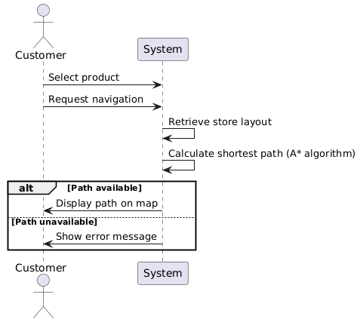

## **2. Use Case: Navigate Shopping List**

### **Use Case Specification**

| **Field** | **Details** |
| --- | --- |
| **Use Case Name** | Navigate Shopping List |
| **Actor** | Customer |
| **Goal** | To calculate and display the optimal path for visiting all products in a shopping list. |
| **Preconditions** | - The customer is logged into the system.  - A shopping list exists.  - The store layout is defined. |
| **Main Flow** | 1. The customer selects a shopping list.  2. The system retrieves the shopping list and store layout.  3. The system calculates the optimal sequence of stops using a heuristic (e.g., TSP approximation).  4. The system calculates paths between each stop.  5. The system displays the full path on the map. |
| **Alternative Flows** | **A1:** If some items are unavailable:  - The system skips those items and recalculates the path. |
| **Error Flows** | **E1:** If no valid paths exist:  - The system displays an error message: "Unable to navigate the shopping list." |
| **Postconditions** | - The optimized path for all items is displayed. |

### **Activity Diagram**

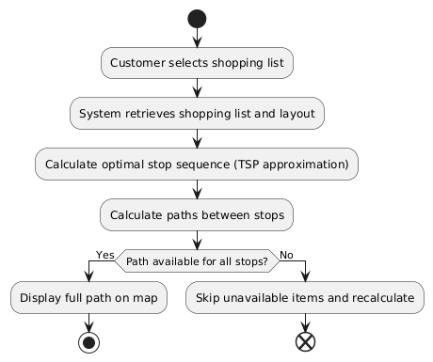

### **Sequence Diagram**

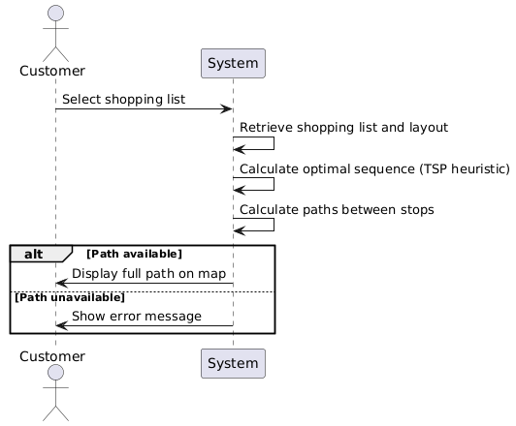

## **3. Use Case: Visualize Store Layout**

### **Use Case Specification**

| **Field** | **Details** |
| --- | --- |
| **Use Case Name** | Visualize Store Layout |
| **Actor** | Customer |
| **Goal** | To allow customers to view and explore the store layout. |
| **Preconditions** | - The customer is logged into the system.  - The store layout is defined and accessible. |
| **Main Flow** | 1. The customer opens the store layout.  2. The system retrieves the layout.  3. The system displays the layout grid with components highlighted (e.g., shelves, aisles).  4. The customer zooms in or out to explore the layout. |
| **Alternative Flows** | **A1:** If the layout fails to load:  - The system displays an error: "Layout not available." |
| **Postconditions** | - The layout is displayed with components visually differentiated. |

### **Activity Diagram**

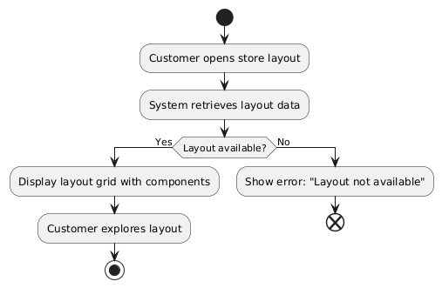

### **Sequence Diagram**

